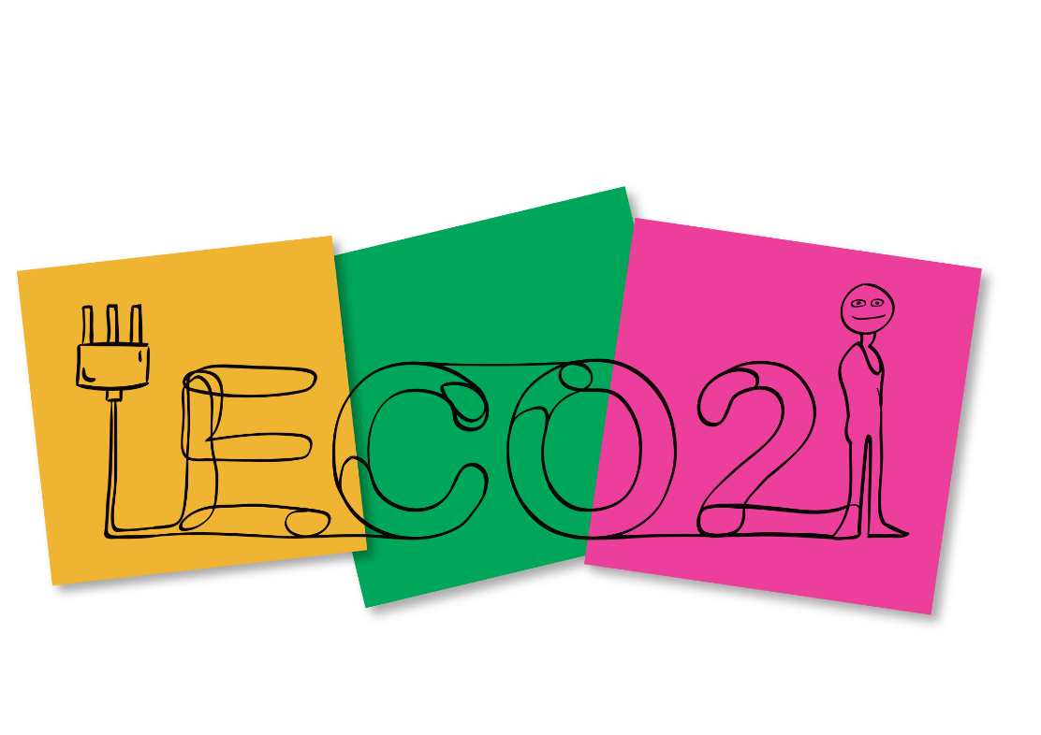

A fresh approach to reducing energy consumption
Energy consumption in Europe needs to be reduced. ECO2 will help energy consumers throughout the European Union to become conscious about their energy consumption and improve their energy efficiency. It is time for a change
For half a century energy consumers have been coaxed, coerced, scolded and persuaded to consume less energy. Why – because consumers are an extremely important part in our transition to sustainable energy. We need to consume energy wisely and preferably from sustainable energy sources.
Energy providers and the public sectors can only do their share of the transition towards a sustainable future. The individual energy consumer must also take part. But how?
Know-how is the way
ECO2 (Energy Conscious Consumers) will engage and empower consumers by giving them knowledge. The measures to consume less energy have multiplied the last decade, the same goes for the devices we use in our daily life. The products themselves might have become more energy efficient, but they pile up in our homes.
ECO2 is a dynamic e-learning platform which through engagement and knowledge sharing will educate consumers on how to consume energy sensibly. It is accessible both as an on-line tool and face to face encounters in the local community. The aim is to be both community building as well as educating, as we want to enable energy consumers in Europe to make home improvements, use energy wisely, and lose bad habits.
Key expected outcomes:
The goal is to reach a minimum of 1000 consumers in the 11 partner countries, totaling 11000 users for the platform. If each of these consumers take three actions, they will save the energy equivalent of 30kg oil, making the expected outcome of ECO2 330.000kg or 4.2~ GWh.
The pilot phases of the project should be considered a user-driven content development process, that ensures high quality, usability and relevance of the content.
Strength in diversity
Behind ECO2 stands an eclectic group of partners from all corners of Europe – experts in energy, IT-usability, e-learning, consumer rights, policy making, user segmentation and public engagement.
This group will develop, test, validate and evaluate what e-learning can accomplish with 11.000 unique users in 11 European countries the next couple of years. But that is just the first part of the project – the final goal is to upscale to all of Europe.
Stay tuned on social media facebook page eco2 and twitter @eco2_eu
If you want to know more about ECO2 please contact project co-ordinator:
Emil Sigbrand esi@tekno.dk
Tel: +45 53 56 05 66

Grant Agreement no. 784988
Activity acronym: ECO2
Activity full name:
Energy Conscious Consumers
